------------------------------------------------- MINI PROJECT 1 -------------------------------------------------------------

Date:06-07-2022

Name of the Student: BOYA DRAVEEN KUMAR   
Name of the trainer: HARSHEE PITRODA  
Course: Machine Learning With Python

Q) You need to create a quiz game in python. The quiz needs to contain 5 questions relating to the subject python. The Quiz game asks the player questions about python. Each correct answer will score a point. At the end of the game, the program will reveal the player’s final score.

You have all freedom to create the quiz game –

* You can have the quiz game as either MCQ based with one correct answer OR you can create a quiz game where the user inputs the answer for the question
* You can give the option of “re-attempt” for the quiz
* You are free to add any more feature

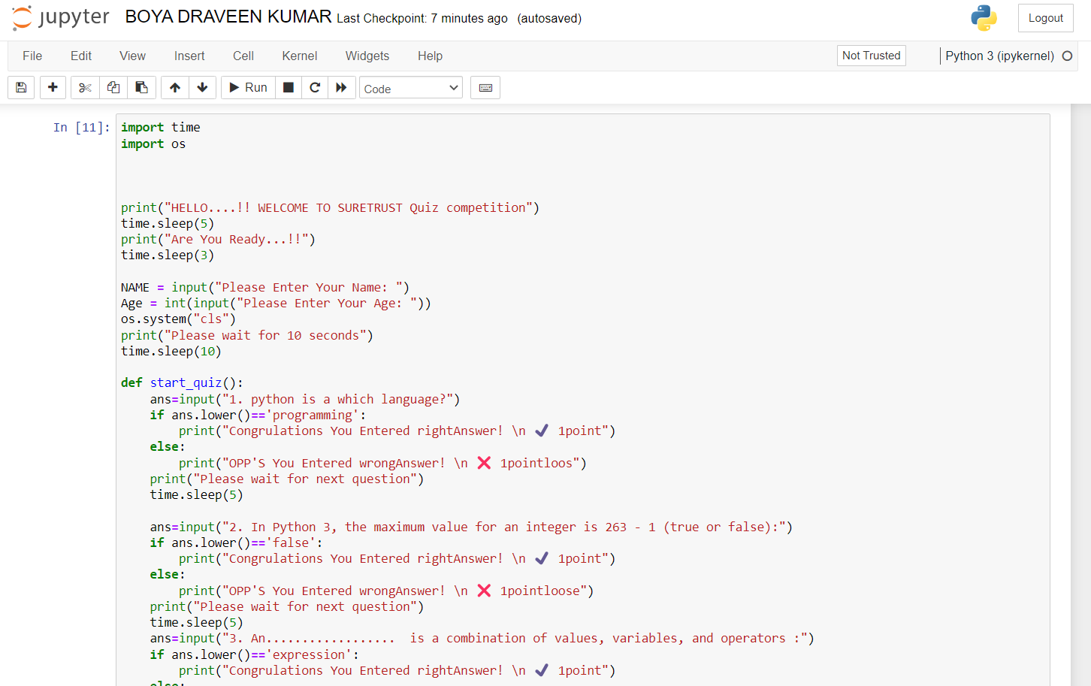

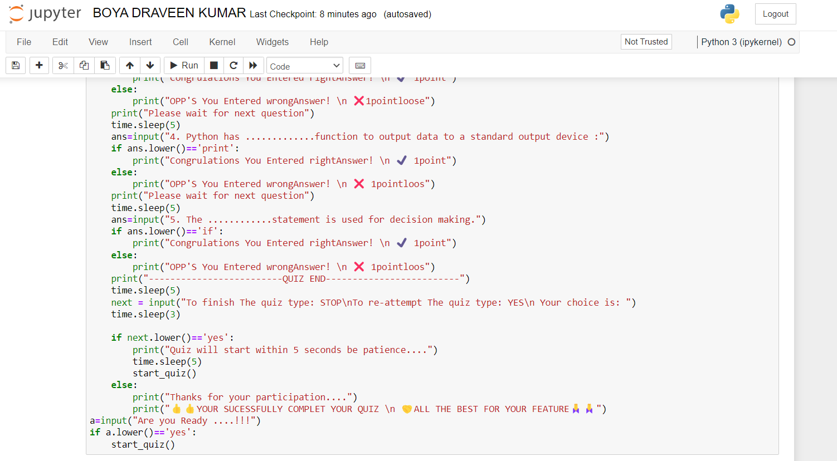

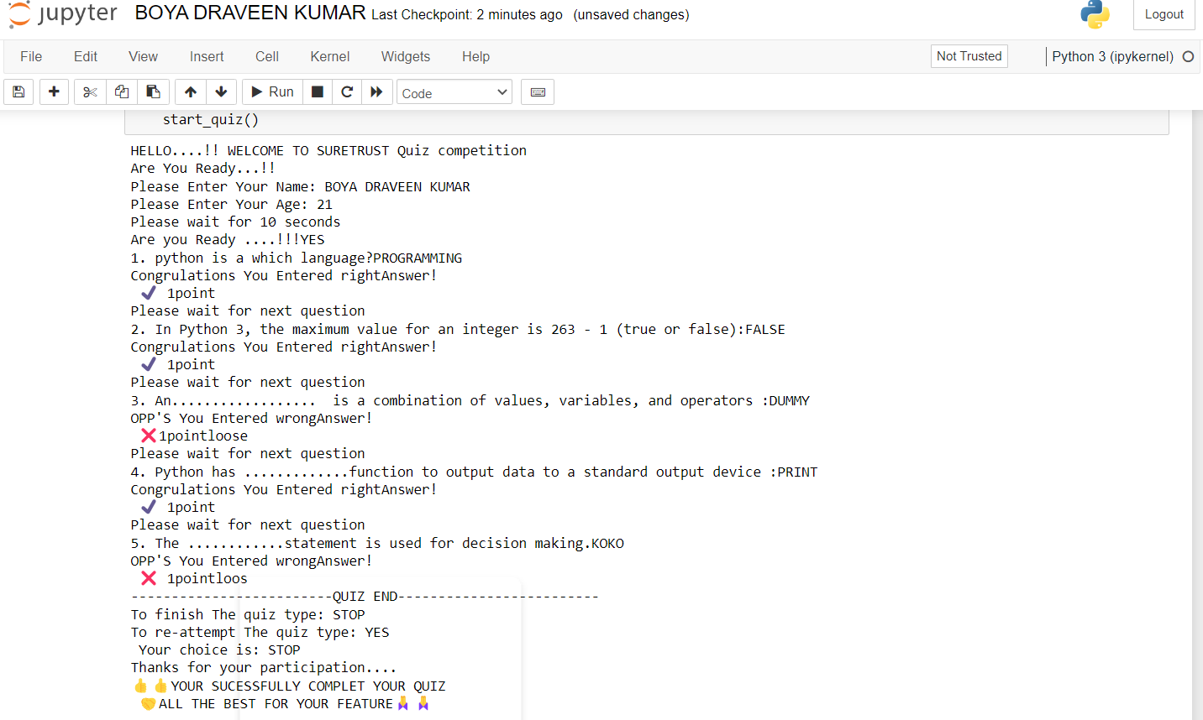

CODE:

import time

import os

print("HELLO....!! WELCOME TO SURETRUST Quiz competition")

time.sleep(5)

print("Are You Ready...!!")

time.sleep(3)

NAME = input("Please Enter Your Name: ")

Age = int(input("Please Enter Your Age: "))

os.system("cls")

print("Please wait for 10 seconds")

time.sleep(10)

def start_quiz():

ans=input("1. python is a which language?")

if ans.lower()=='programming':

print("Congrulations You Entered rightAnswer! \n ✔️ 1point")

else:

print("OPP'S You Entered wrongAnswer! \n ❌ 1pointloos")

print("Please wait for next question")

time.sleep(5)

ans=input("2. In Python 3, the maximum value for an integer is 263 - 1 (true or false):")

if ans.lower()=='false':

print("Congrulations You Entered rightAnswer! \n ✔️ 1point")

else:

print("OPP'S You Entered wrongAnswer! \n ❌ 1pointloose")

print("Please wait for next question")

time.sleep(5)

ans=input("3. An.................. is a combination of values, variables, and operators :")

if ans.lower()=='expression':

print("Congrulations You Entered rightAnswer! \n ✔️ 1point")

else:

print("OPP'S You Entered wrongAnswer! \n ❌1pointloose")

print("Please wait for next question")

time.sleep(5)

ans=input("4. Python has .............function to output data to a standard output device :")

if ans.lower()=='print':

print("Congrulations You Entered rightAnswer! \n ✔️ 1point")

else:

print("OPP'S You Entered wrongAnswer! \n ❌ 1pointloos")

print("Please wait for next question")

time.sleep(5)

ans=input("5. The ............statement is used for decision making.")

if ans.lower()=='if':

print("Congrulations You Entered rightAnswer! \n ✔️ 1point")

else:

print("OPP'S You Entered wrongAnswer! \n ❌ 1pointloos")

print("-------------------------QUIZ END-------------------------")

time.sleep(5)

next = input("To finish The quiz type: STOP\nTo re-attempt The quiz type: YES\n Your choice is: ")

time.sleep(3)

if next.lower()=='yes':

print("Quiz will start within 5 seconds be patience....")

time.sleep(5)

start_quiz()

else:

print("Thanks for your participation....")

print("👍👍YOUR SUCESSFULLY COMPLET YOUR QUIZ \n 🤝ALL THE BEST FOR YOUR FEATURE🙏🙏")

a=input("Are you Ready ....!!!")

if a.lower()=='yes':

start_quiz()

INPUT/OUTPUT

HELLO....!! WELCOME TO SURETRUST Quiz competition

Are You Ready...!!

Please Enter Your Name: BOYA DRAVEEN KUMAR

Please Enter Your Age: 21

Please wait for 10 seconds

Are you Ready ....!!!YES

1. python is a which language?PROGRAMMING

Congrulations You Entered rightAnswer!

✔️ 1point

Please wait for next question

2. In Python 3, the maximum value for an integer is 263 - 1 (true or false):FALSE

Congrulations You Entered rightAnswer!

✔️ 1point

Please wait for next question

3. An.................. is a combination of values, variables, and operators :DUMMY

OPP'S You Entered wrongAnswer!

❌1pointloose

Please wait for next question

4. Python has .............function to output data to a standard output device :PRINT

Congrulations You Entered rightAnswer!

✔️ 1point

Please wait for next question

5. The ............statement is used for decision making.KOKO

OPP'S You Entered wrongAnswer!

❌ 1pointloos

-------------------------QUIZ END-------------------------

To finish The quiz type: STOP

To re-attempt The quiz type: YES

Your choice is: STOP

Thanks for your participation....

👍👍YOUR SUCESSFULLY COMPLET YOUR QUIZ

🤝ALL THE BEST FOR YOUR FEATURE🙏🙏